Ecopath with Ecosim technical papers:
Sharing external spatial-temporal data



EwE development team
Ecopath Research and Development Consortium
Ecopath International Initiative, University of British Columbia

Abstract
With the introduction of the Spatial Temporal Data Framework (e.g., framework), Ecospace, the spatial-temporal module of the EwE modelling approach, gained the possibility to vary its input maps over time via time series of maps that are available outside a EwE model. The framework is described in detail in Steenbeek (2012) and Steenbeek et al (2013). For the purpose of this document, the structure of the framework, and the terms ‘dataset’, ‘converter’, and ‘adapter’, are presumed to be familiar and can be obtained from Steenbeek (2012) and Steenbeek et al (2013).
Because EwE modellers share models, external data connections need to be shared as well. Facilities to export and share external data configuration between software users was added to the development version of EwE 6.5, which allows models to retain their data accessibility across computers, but has also complicated the process of configuring Ecospace scenarios to a point that can become rather confusing.
This document describes the structure of sharing external data, and provides recommendations how to improve this structure.

Keywords
Ecopath with Ecosim, EwE, Ecospace, Spatial Temporal Data Framework, GIS, Sharing

Credits
This document is written and maintained by the technical committee of the Ecopath Research and Development, Ecopath International Initiative Research Association, Spain.
This document is published as an Ecopath with Ecosim (EwE) technical paper.
The contents of this document is subject to the Ecopath with Ecosim L-GPL license version 2.0

Version history
Date | Version | Author | Description
2015-03-03 | 1.0 | Jeroen Steenbeek | Initial version

Suggested citation:
Steenbeek, J. (2019), Ecopath with Ecosim technical papers: Sharing external data. Ecopath International Initiative

External data
In the context of the Spatial Temporal Data Framework, the term ‘external data’ refers to any data not embedded within a EwE model database, and is thus external to the EwE model.
By its design, the framework allows external data connections to any source: local or remote files, web services, THREDDS and OpenDap connections, and running models are among possibilities. To date, only file-based access has been implemented for the framework.
The Ecospace module of the Ecopath with Ecosim (EwE) software recently gained capabilities to be driven by external spatial-temporal datasets, a feature that would be extensively used for the 2017 Coastal Master Plan community model. These external data sets cannot be embedded within a EwE model because they tend to be model-derived datasets that frequently update and that are of prohibitive file size. The process of connecting to these data is detailed in Steenbeek et al. (2013).
As modeling exercises are increasingly executed by scientists of different institutes in different locations, this system needed to be extended to offer support for shared use of Ecospace models with accompanying external spatial data via cloud-based transfer media.

2.3.1 Changes to EwE
The Ecospace model stores definitions of available spatial-temporal data series in a local configuration file (Steenbeek et al., 2013). Sharing this configuration file is Impractical when a local system contains dataset definitions for a suite of Ecospace models: support was needed to only selectively share relevant data for a given modeling exercise. To enable this, the following changes have been made to the EwE6 software:
- An export function was added to EwE6 that allows a user to copy a selection of dataset definitions to a local folder with a local configuration file. Whereas datasets on a local system are indicated by absolute file paths, the exported datasets refer to their files via local paths, making this export folder highly suitable for transfer to another computer.
- An option has been added to allow users to switch to another configuration file – either locally created configuration files particular to a given modeling exercise, or shared configuration files obtained via a cloud-based file transfer system - which will provide Ecospace with access to the external spatial-temporal data connections described in the configuration file.
EwE6 model databases already carried all information needed to connect an Ecospace layer to external data sets (Steenbeek 2013). However, this information just contained technical details internal to the model, and was too sparse to assist troubleshooting when expected data sets could not be located. The following changes have been made to the EwE6 software:
- EwE6 model databases now also store the configuration of data sets, but not the actual data due to its prohibitive size.
- When Ecospace loads this information it tries to resolve these data sets. If a local computer does not know these data sets, the data sets are instantiated from the data stored in the model, and the user is warned that the data set may be incomplete. Having access to the complete configuration information, a user can figure out what external data is needed to reassemble the model configuration by requesting a data set export from the original model author, and then linking to these data.

2.3.2 Using the new developments
Users can export data sets from several locations in EwE, such as the main Ecospace menu and the interface where external datasets are defined (Figure1).
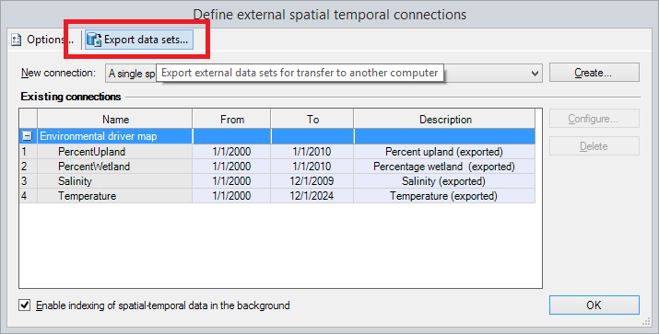
Figure 1 - Where to find the "Export data sets" option

When this option is selected, a dedicated interface is displayed where users can decide which data sets to export for transfer to another computer, such as all data sets or only those used by the current model (Figure 2).
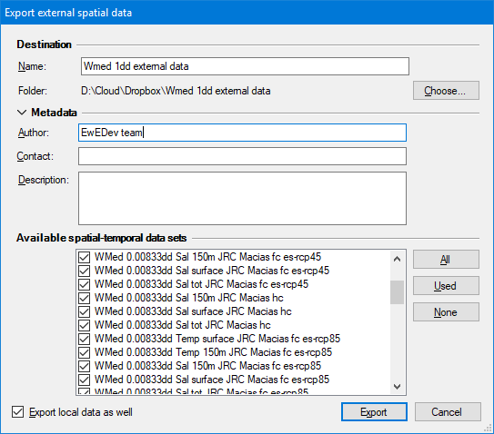
Figure 2 - Data set export interface

The EwE6 status panel notifies the user where where the data sets have been exported to. When clicking this link, users are brought to the export directory which in its entirety can be transferred to another computer, or can be shared via a cloud-based service such as Dropbox. The Export folder contains directories with file content for individual data sets where applicable, and a configuration file for these files (Figure 3).
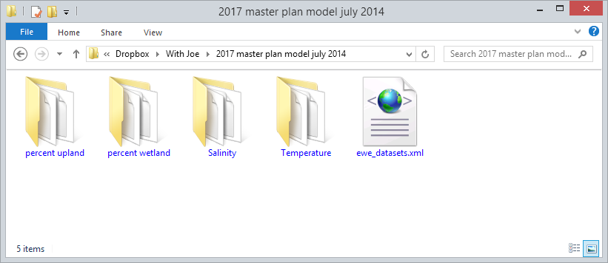
Figure 3 - Example contents of a data set export folder

Once the exported data sets are transferred to another computer they can used by EwE. For this, a user switches the local configuration to the exported data sets via the spatial temporal data page in the main EwE options interface (Figure 2.10). Ecospace now shows the data sets as usable for the model (Figure 4).

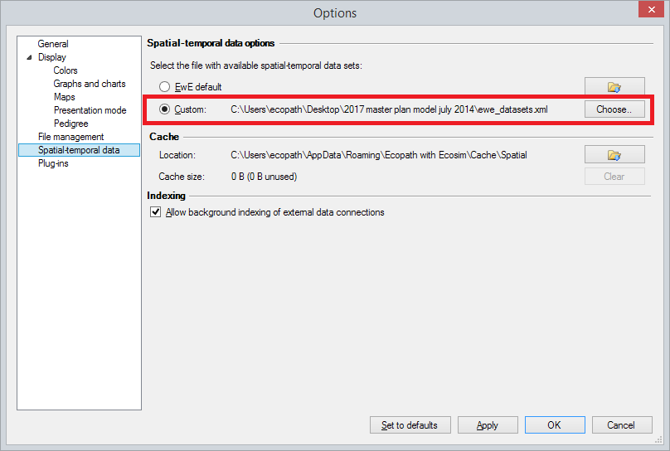
Figure 4 - Linking to a set of exported data sets that has been received from another user

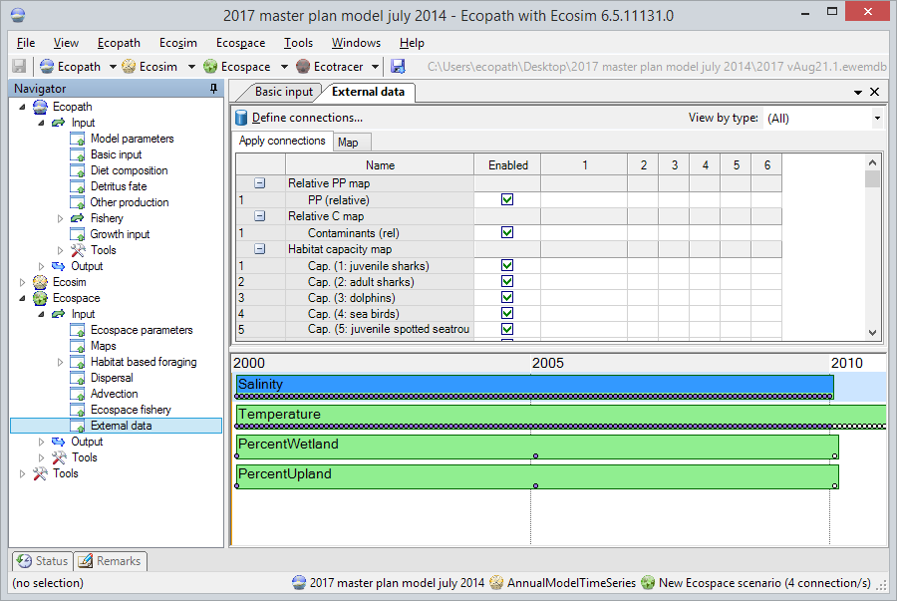
Figure 5 - The imported data sets displayed in Ecospace and ready to be used

References
Steenbeek, J., 2012. Bridging the gap between ecosystem modelling tools using geographic information systems (MSc). Manchester Metropolitan University, Manchester.
Steenbeek, J., Coll, M., Gurney, L., Mélin, F., Hoepffner, N., Buszowski, J., Christensen, V., 2013. Bridging the gap between ecosystem modelling tools using geographic information systems: driving a food-web model with spatial-temporal primary production data. Ecol. Model. 263, 139–151. doi:2013

